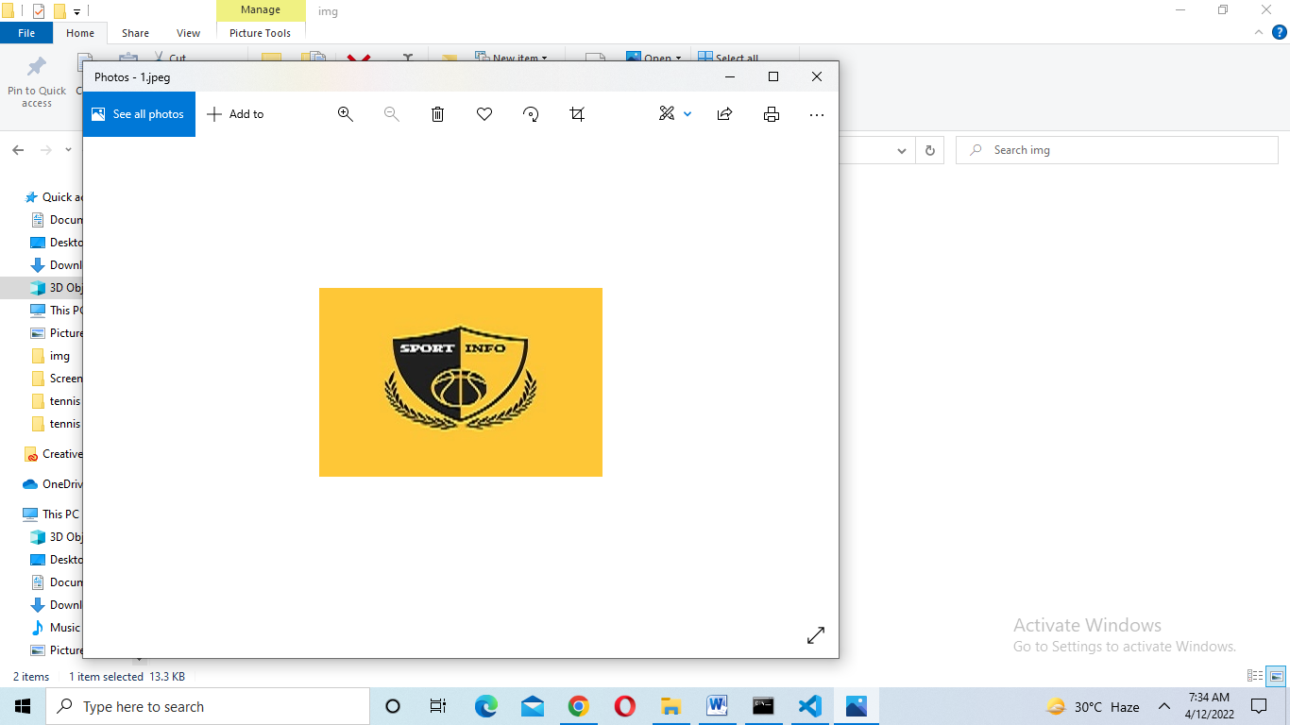

SPORTS INFO .COM

|  |  |  |  |
| --- | --- | --- | --- |
| Supervior. | Sir Ashir Irfan | | |
| Batch. | PR2-202110G | | |
| Group. |  | | |
| Serial No. | | Enrollment Number | Student Name |
| 1. | | Student1340500 | Arisha Shahzad |
| 2. | | Student1333808 | M. Hamza Khan |
| 3 | | Student1340502 | Tasmeet Javeed |

# ACKNOWLEDGEMENT

The first, we would like to express my special thanks of gratitude to my teacher Sir Ashir Irfan, who helped us a lot in finalizing this project within the limited time frame, valuable counselling and assistance for the accomplishment of this project.

Secondly we would also like to thank the eProject team at Aptech Head Office, who gave us the golden opportunity to do this wonderful project about Aura Watch.

Thirdly, we also thank the eProject team, some of the benefits are as under:

* Re-enforcement of skills happens in the experiential learning process.
* A mentor, ensuring that we do not get drifted, constantly guides us.
* It gives us a lot of confidence to face an interview as we have worked on a project. We can explain virtually everything on the subject we have learnt.

# SYNPOSIS

The Objective of this program is to give a sample project to work on real life projects. These applications help you build a larger more robust application.

The objective is not to teach you the software’s but to provide you with a real life scenario and help you create basic applications using the tools.

You can revise the topics before you start with the project.

These programs should be done in the Lab sessions with assistance of the faculty if required.

It is very essential that a student has a clear understanding of the subject.

Kindly get back to eProjects Team in case of any doubts regarding the application or its objectives.

# PROBLEM DEFINITION

*Infocom* is a multi national company that builds informative sites. i.e. *CellInfo.com* site gives all the information about cell phones, *LibertyElectronics.com* gives information about various electronics products and so on. Now the company has decided to develop a site *sportsinfo.com* where the user will get information related to sports. The developers in the company are currently working on many other projects because of which development of the *sportsinfo.com* is getting delayed. Hence the company wants you to develop the site for them.

# CUSTOMER REQUIREMENT SPECIFICATION (CRS)

**Customer Expectation**

***sportsinfo.com*** needs to be constructed considering following requirements:

1. Home page with suitable logo.
2. A menu which will include all the functions implemented in the site.
3. The site should provide the information about following sports:
   1. Football
   2. Judo
   3. Tennis
   4. Motorcycle Racing
   5. Volleyball
   6. Golf
   7. Chess
   8. Billiards
   9. Badminton
   10. Swimming
   11. Athletics.

Apart from the above mentioned sports, you may add other sports of your choice.

1. The information about a particular sport should include:
   1. How many players play the game?
   2. Strategy of the game.
   3. Is it a team game?

d .Rules of the game.

e. Some important facts about the game (when was the game invented, any special tournament like World cup / Wimbledon is played etc etc).

1. Statistics/ records.
2. Also include the images of the players, clicking on which should display the detailed information about that player.

h.Which all countries play this game?

1. The user should be able to search a particular sport.
2. Maintain the guestbook as an additional feature just to keep information about the users that visited the site. Guestbook information includes name, email, date of visit, address, comment about the site, whether visitor will recommend the site to others or not etc. Also ask the visitor to rate the site (rating levels 1-Excellent, 2-Good, 3-Average, 4-Poor).
3. Provide a ‘About Us’ page which will introduce the company.
4. There should be a “Contact Us” page which will have the Address of the Company and the mail address which when clicked will invoke the local mail client from where they can send an email.
5. The site should have appropriate look and feel suitable to company’s reputation and status.

# SCOPE OF THE WORK (IN BRIEF)

The website is to be developed for the Windows Platform using HTML5, JavaScript and Geolocation. The site should work well in all leading browsers including Chrome, IE, Firefox etc..

Homepage show Top best sell items, big sale, collection, new shop...

Every content direct to relative content.

# AGGREGATED SITEMAP

SPORTS INFO.COM

(1.Welcome.html)

SPORTS INFO.COM

(0.Welcome.html)

# SITEMAP ENGLISH

Circket

(circket.html)

(

(Circket.html)

Sports info.com

(1.index.html)

Football

(Football.html)

Tennis

(Tennis.html)

Sports Name

Sports

(5.sports.html)

Feedback

(4.Feedback .html)

Contact us

(3.contact us .html)

About us

(2.About us.html)

Home Page

(1.index.html)

Badmintion

(badmintion.html)

Swimming

(swimming.html)

(

Motorcycle racing (motorcycle racing.html)

l)

Volleyball

(Volleyball.html)

Chess

(Chess.html)

Judo

(Judo.html)

Billiards

(billards.html)

Golf

(golf.html)

Athletics

(Athetics.html)

# 1.HOME PAGE

|  |
| --- |
| HOME ABOUTUS CONTACTUS FEEDBACK SPORTS |

|  |
| --- |
|  |
| SLIDE |

ABOUT US

IMAGES

IMAGES

IMAGES

 Sports Gallery



CONTACT US

EMBAD MAP FORM

FOOTER

# 2.ABOUT US PAGE

|  |
| --- |
| HOME ABOUT US CONTACT Us FEEDBACK SPORTS |

|  |
| --- |
| BACKGROUND |

|  |  |
| --- | --- |
| |  | | --- | | Image |   ABOUTUS  Lorean ipsun is simply dummy text of the printing  And typesetting industry. Lorem ipsum has been the  Industry. |

FOOTER

# 3.CONTACT US

|  |
| --- |
| HOME ABOUT US CONTACT US FEEDBACK SPORTS |

|  |
| --- |
| BACKGROUND |

|  |
| --- |
| **Lorem Ipsum** is simply dummy text of the printing and typesetting industry. Loremipsum has been the industry's standard dummy text ever since the 1500s, when an unknown printer took a galley of type and scrambled it to make a type specimen book.  Social media links  Facebook Twitter You tube Google |

|  |
| --- |
| MAP EMBAD FORM |

FOOTER

# 4.FEEDBACK

|  |
| --- |
| HOME ABOUT US CONTACT US FEEDBACK SPORTS |

|  |
| --- |
| Background |

|  |
| --- |
| CREATE AN ACCOUNT  First Name  Middle Name  Last Name  Phone  Address  Gender  TextBox  CREATE ACCOUNT |



# 5.Sports

12 Sports

1 CIRCKET

2 BADMINTION

3 TENNIS



4 VOLLEY BALL

5 GOLF

6 CHESS

7 BILLIARDS

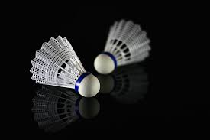8 MOTORCYLE RACING

9 SWIMMING

10 JUDO

11 FOOTBALL

12 ATHLETICS



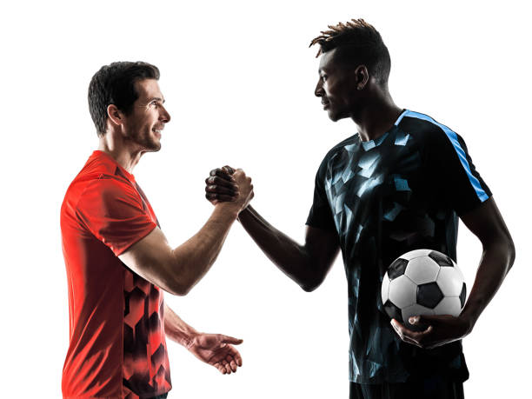

# TASK SHEET REWIEW 2

|  |  |  |  |  |  |  |  |
| --- | --- | --- | --- | --- | --- | --- | --- |
| Project Ref. No.: | |  |  |  |  |  |  |
| eP/Advertisement | | Project | Date of Preparation of Activity Plan | | | |  |
| Portal Management | | title |  |  |  |  |  |
|  | System/01 |  |  |  |  |  |  |
| No | Task |  | Actual | Actual | Team-mate | Status |  |
|  |  |  |  |  |
|  | Start Date | Days | Names |  |
|  |  |  |  |  |
| 1 | Build Home |  | DD/MM/YY | 4 | Hamza | Complete |  |
| Page |  |  |  |
|  |  |  |  |  |  |  |
|  | Build About us  Page |  | DD/MM/YY |  | Tasmeet |  |  |
| 2 |  |  | 2 | complete |  |
|  |  |  |  |
|  |  |  |  |  |
|  |  |  |  |  |  |  |
|  |  |  |  |  |  |  |  |
|  | Build Contact us Page |  |  |  |  |  |  |
| 3 |  |  | DD/MM/YY | 2 | Arisha | Complete |  |
|  |  |  |
|  |  |  |  |
|  |  |  |  |  |  |  |  |
|  |  |  |  |  |  |  |  |
| 4 | Build Feedback  Page | SPORTSINFO.COM | DD/MM/YY | 2 | Hamza | Drop Out |  |
|  |  |
|  |  |  |  |  |  |  |
|  |  |  |  |  |  |  |  |
| 5 | Build Sports pages | DD/MM/YY | 5 | Hamza  Tassmeet  Arisha | Complete |  |
|  |  |  |  |
|  |  |  |  |
|  |  |  |  |  |  |  |  |

# TASK SHEET REVIEW 3

|  |  |  |  |  |  |  |  |  |  |  |  |  |  |  |
| --- | --- | --- | --- | --- | --- | --- | --- | --- | --- | --- | --- | --- | --- | --- |
| Project Ref. No.: | | |  | |  | |  | |  | |  | | |  |
| eP/Advertisement | | | Project | | Date of Preparation of Activity Plan | | | | | | | | |  |
| Portal Management | | | title | |  | |  | |  | |  | | |  |
|  | System/01 | |  | |  | |  | |  | |  | | |  |
| No | Task | |  | | Actual | | Actual | | Team-mate | | Status | | |  |
|  | | Start Date | | Days | | Names | |  |
|  |  | |  | |  | | |  |
|  | Check color | |  | |  | |  | |  | |  | | |  |
| 1 | format, size, | |  | | DD/MM/YY | | 2 | | Hamza | | Complete | | |  |
| javascript, | |  | |  |
|  | |  | |  |
|  | responsive in the | |  | |  | |  | |  | |  | | |  |
|  | Home page | |  | |  | |  | |  | |  | | |  |
|  | Check color | |  | |  | |  | |  | |  | | |  |
|  | format, size, | |  | |  | |  | | Tasmeet | |  | | |  |
| 2 |  | |  | | DD/MM/YY | | 2 | | Complete | | |  |
| Responsive in | |  | |  | |  |
|  |  | |  | |  | |  | |  | | |  |
|  | About us page | |  | |  | |  | |  | |  | | |  |
|  |  | |  | |  | |  | |  | |  | | |  |
|  | Check color | | Sports info.com | |  | |  | |  | |  | | |  |
|  | format, size, | |  | |  | |  | |  | | |  |
|  |  | |  | |  | |  | |  | | |  |
|  |  | |  | |  | |  | |  | | |  |
|  |  | |  | |  | |  | |  | | |  |
| 3 | responsive in | |  | | DD/MM/YY | | 2 | | Arisha | | Complete | | |  |
| Contact us page | |  | |  | |  |
|  |  | |  | |  | |  | |  | | |  |
|  |  | |  | |  | |  | |  | |  | | |  |
|  |  | |  | |  | |  | |  | |  | | |  |
|  |  | |  | |  | |  | |  | |  | | |  |
| 4 | Feedback |  | |  | |  | | hamza | |  | |  |
|  |  | |  | | 2 | | Complete | |  |
|  |  | | DD/MM/YY | |  |
|  |  |  | |  | |  |
|  |  |  | |  | |  |
|  | |  | |  | |  | |  | |  |
|  |  | |  | |  | |  | |  | |  |
|  |  | |  | |  | |  | |  | |  |
|  | Overall |  | |  | |  | | arisha | |  | |  |
| 5 |  | |  | | 4 | | hamza | | Complete | |  |
| inspection of the project |  | | DD/MM/YY | |  |
|  | | tasmeet | |  |

